**Name:** Gunawardana M.A.A.

**SID:** IT24103038

**Module:** PS

**Labsheet:** 08



Answers:

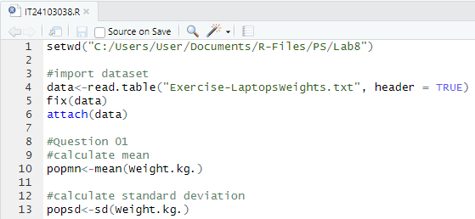



Answers:

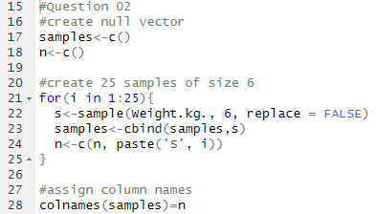



Answers:

